Algeria

## GNI per capita and development level

The data set shows the GNI per capita and development level of the country each year.

## # A tibble: 19 x 5  
## country iso3c date GNIperCapita devCategory   
## <chr> <chr> <dbl> <dbl> <chr>   
## 1 Algeria DZA 1996 3202. Lower Middle Income  
## 2 Algeria DZA 1998 3331. Lower Middle Income  
## 3 Algeria DZA 2000 3433. Lower Middle Income  
## 4 Algeria DZA 2002 3666. Lower Middle Income  
## 5 Algeria DZA 2003 3874. Lower Middle Income  
## 6 Algeria DZA 2004 3977. Lower Middle Income  
## 7 Algeria DZA 2005 4112. Upper Middle Income  
## 8 Algeria DZA 2006 4144. Upper Middle Income  
## 9 Algeria DZA 2007 4318. Upper Middle Income  
## 10 Algeria DZA 2008 4378. Upper Middle Income  
## 11 Algeria DZA 2009 4366. Upper Middle Income  
## 12 Algeria DZA 2010 4469. Upper Middle Income  
## 13 Algeria DZA 2011 4477. Upper Middle Income  
## 14 Algeria DZA 2012 4501. Upper Middle Income  
## 15 Algeria DZA 2013 4524. Upper Middle Income  
## 16 Algeria DZA 2014 4602. Upper Middle Income  
## 17 Algeria DZA 2015 4670. Upper Middle Income  
## 18 Algeria DZA 2016 4790. Upper Middle Income  
## 19 Algeria DZA 2017 4729. Upper Middle Income

## GDP growth and economic growth classification

The data set shows the GDP growth and the ecomic growth classification of the country each year.

## # A tibble: 19 x 5  
## country iso3c date GDPannualGrowthRate GDPgrowthCategory4  
## <chr> <chr> <dbl> <dbl> <fct>   
## 1 Algeria DZA 1996 4.10 moderate growth   
## 2 Algeria DZA 1998 5.10 moderate growth   
## 3 Algeria DZA 2000 3.8 moderate growth   
## 4 Algeria DZA 2002 5.60 fast growth   
## 5 Algeria DZA 2003 7.2 fast growth   
## 6 Algeria DZA 2004 4.30 moderate growth   
## 7 Algeria DZA 2005 5.90 fast growth   
## 8 Algeria DZA 2006 1.7 slow growth   
## 9 Algeria DZA 2007 3.40 moderate growth   
## 10 Algeria DZA 2008 2.4 slow growth   
## 11 Algeria DZA 2009 1.6 slow growth   
## 12 Algeria DZA 2010 3.60 moderate growth   
## 13 Algeria DZA 2011 2.9 moderate growth   
## 14 Algeria DZA 2012 3.40 moderate growth   
## 15 Algeria DZA 2013 2.8 moderate growth   
## 16 Algeria DZA 2014 3.80 moderate growth   
## 17 Algeria DZA 2015 3.7 moderate growth   
## 18 Algeria DZA 2016 3.20 moderate growth   
## 19 Algeria DZA 2017 1.30 slow growth

## Development trend

The plot shows the development trend of the country.

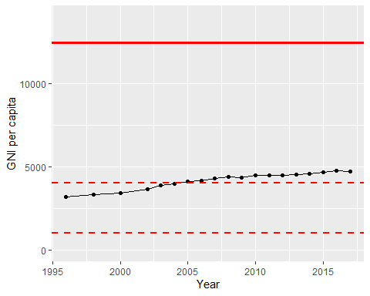

GNI Per Capita Trend